_____________________________________________________

Gebze Technical University

The History of Computer

Melih Yabaş
161044072

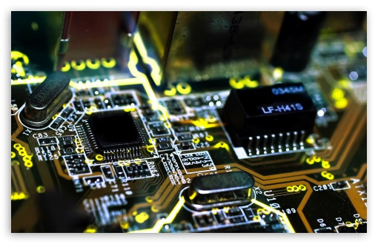

17.09.2017

_____________________________________________________________

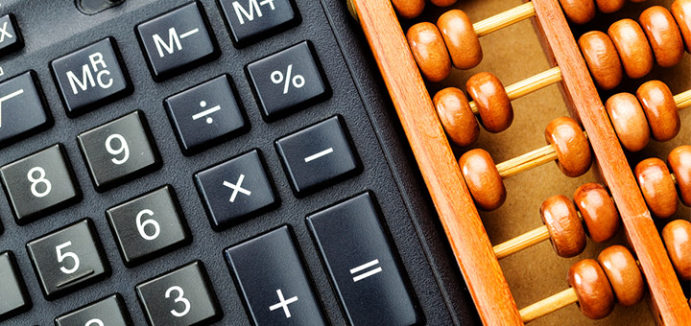

What is a Computer?
Computers are devices that do calculating, arrangement and many other work.

A computer can keep your mass information in a small place. If you want, you can access them in a short time.

Hardware of computers consist of some sections. These are; entry units, transaction units, output units.

Entry units are keyboard, mouse and scanner.
Transaction unites are CPU, CU, ALU, RAM, HDD, FDD and CD-ROM.
Output units are monitor, printer, scriber, modem, ethernet card, headphone, speaker.

Modern computers has different functions. These fuctions are governed by OS. So OS and computer work together.

Hardware means the physical parts of computers. The other parts are software.

Many people think many devices are computers. These devices are abacus and calculator. However, there are people who disagree with that.

The Computer Which in Past to Today

Abacus that is a kind of simple calculator is the first computer for a lot of sources.
The first abacus has been made almost 2000 years ago.
The first mechanic calculator was made by Blaise Pascal in 1642. However that was not a good machine.

The first advanced calculator was made by Gottfreid Wilhelm von Leibniz in 1671. This machine has worked with gears.
Then some scienstist developed the calculator.

Howard Hathaway Aiken made an electronical calculator in 1937. The calculator could calculate logarithm and trigomometry function. Aikens machine was slow but it has lots of advantages.

In 1945, During World War II, armies needed fast computers. So, ENIAC was made in 1945. ENIAC is the first computer that includes electron tubes and RAM.
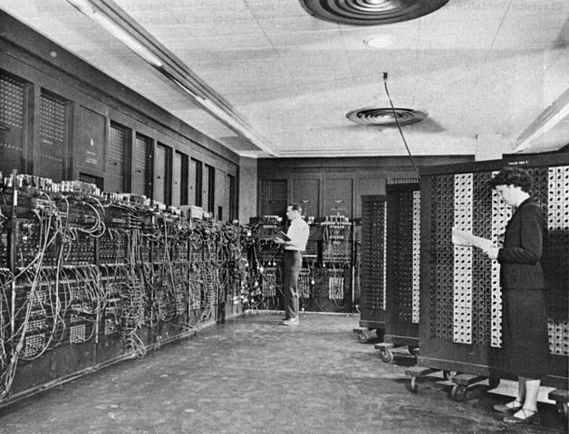

(ENIAC almost 167 m²)

Computers can be used in a lot of places with softwares that made by programming languages.

Today, everyone has a computer. We can carry them in our pockets

Laptops

A laptop is a computer which consist of a screen and a keyboard. Laptops have advantages in terms of size and portability.

The first portable DOS computer has been made by Siemens Nixdorf in 1985.
Sony and Compac are the first companies which produce laptop.
The main purpose of laptop production is portable using.

In the first production, laptops were too expensive. However, now, a lot of people can easily buy them.
Modern laptop computers can contest the others anymore.

